File Types
Any item in the document exchange has a ‘type’ assigned to it. There are three base types: a folder (due to legacy issues this is called a collection in the data layer), a file, or a hyperlink. This list can be extended. In fact DMX stores for every entry in its database an entry type key so that it knows what it can do with it. This key is a string of terms separated by dots much like namespaces in programming, with the more general terms on the left and more specific terms on the right. So an acrobat file, for instance, is known as an entry of type “File.Adobe.Acrobat”, and a folder is a “Collection” (see note below). You can see that this way we can define more types later on as we need to extend the functionality of the system.
For the types that have general applicability within the core DMX we can tune appearance and behaviour. Most notably we can define:
- To which file extensions the type applies
- Which icons are used to display
- Whether to view an item within a web browser, or to push the browser to download the item when the item’s icon is clicked.
- The mime-type to send to the browser when sending the file for viewing
Note that there are other settings for file types such as setting a control to load, but these settings are meant to tune interaction with add-ons to DMX. For now we will concentrate on the aspects mentioned above.

Semantics: Folder vs Collection
Since version 4, we speak of folders in document exchange. In previous versions a folder was called a collection. In various parts of the data model and on some administration screens you might still run into the term collection (all effort is made to shield the end user from this word). Be aware that the collection is a legacy term for folder much like ‘tab’ is a legacy term for ‘page’ in DNN.

Editing File Types
Although you may never need to edit or add to the file types, the option is there for you. When you edit these note that this governs all DMX instances in the portal. You get to the edit screen through either the Admin menu on a DMX module or through the DMX Control Panel.
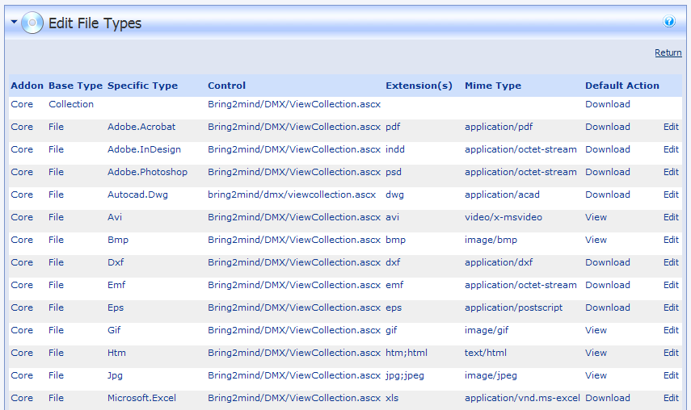
You can modify and extend the type list by going to ‘File Types’ on the admin’s menu in DMX. Clicking edit will bring up the edit screen as shown below:
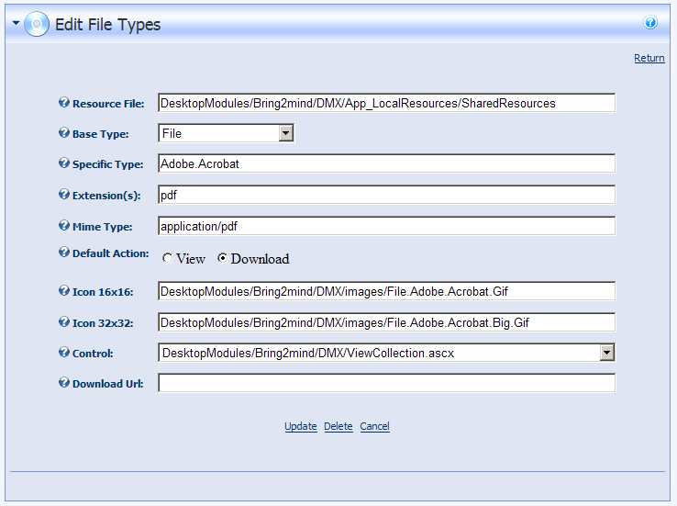

Resource File
This is where DMX can look up the proper localized name for the file. Consult the SharedResources file of DMX to see examples.

Type name
The base type is fixed in the DMX core and can be only one of ‘File’, ‘Collection’, or ‘Hyperlink’. For the time being we will only concern ourselves with the base type ‘File’ (the other base types have no possibility for specific tuning in the core DMX). The specific type is added to this and should be some descriptive combination of terms that narrow down the entry type. It is up to you to choose a good key.

File extensions
Specify a semi-colon separated list of extensions (without the period). When someone uploads a document, the extension is used to find a file type that matches. This is also used during bulk import (both admin and using zip file)

Mime type
Browsers use mime-types to determine the nature of the data that is sent to them. You can quite easily find resources on the internet describing the various possibilities for this setting. The default type for binary data is ‘application/octet-stream’ and will most likely cause the browser to prompt the user to save the incoming data. If, however, it receives data as ‘image/jpeg’, then it will try to display that as a jpeg picture.

Default action
There are two ways in which a user accesses a file that is on the server’s hard disk. Either through clicking ‘download’ on the details screen (or the download icon on the listing screen), or by clicking the file icon on one of the collection lists. Clicking the file’s own icon will prompt DMX so send the file to the user’s browser. This can be done either as an attachment, or as contents of a page to display. The first will lead to a download prompt being displayed; the second will lead the browser to attempt to display the file (by optionally loading a plugin, such as the acrobat reader for instance).
Note that browser behaviour is notoriously erratic when trying to get them to display items. It varies wildly by brand and version. There are numerous resources on the net about this, and many many more fierce discussions about which browser does this best.

Icons
Nice icons are the icing on the cake. You can specify which icons to use for the file type. There are two sizes: 16 by 16 pixels, and 32 by 32 pixels. The first is used in file listings, the latter is used at the top of the details screen.

Control
By default the control to load when viewing a file should be set to “Bring2mind.DMX/ViewDetails.ascx”. It is recommended to leave it to that. When you also have add-ons to DMX on your site, you might opt to show another screen when viewing a particular item type.

Download Url
Leave this blank for default download behaviour. Specify ‘False’ to prevent downloading of this type. Specify a specific asp.net page to provide custom download handling.

